How to write a professional email
Writing a professional email may seem obvious to you but I am surprised at some of the messages that appear in the inbox. While I understand most of these are quickly written in textspeak on a phone, they do not create a great impression. Think about how you present yourself, especially to an instructor, professor, potential boss, real boss, etc.
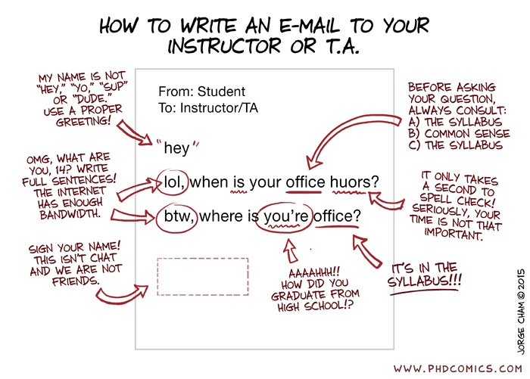

Also have a look at your email address.
What is it saying about you? Years ago, a grade 11 student sent me an assignment they were missing at the end of the year. There was no name on the assignment or message so I had a look at the email address which was something like cupcakes52@... Now, I had 4 grade 11 blocks filled to 30 students that year, and was chasing down several students who needed to get their work in. I asked my classes who cupcakes was. No one owned up to it. It’s hard to be taken seriously when you go by cupcakes.

So think about how you are presenting yourself to the world when you send an email.

